SCHOOL OF COMPUTER SCIENCE AND ARTIFICIAL INTELLIGENCE |  |  |  |  | DEPARTMENT OF COMPUTER SCIENCE ENGINEERING
Program Name: B. Tech |  |  |  | Assignment Type: Lab |  |  | Academic Year:2025-2026
Course Coordinator Name |  |  |  | Venkataramana Veeramsetty
Instructor(s) Name
  Dr. V. Venkataramana (Co-ordinator)
  Dr. T. Sampath Kumar
  Dr. Pramoda Patro
  Dr. Brij Kishor Tiwari
  Dr.J.Ravichander
  Dr. Mohammand Ali Shaik
  Dr. Anirodh Kumar
  Mr. S.Naresh Kumar
  Dr. RAJESH VELPULA
  Mr. Kundhan Kumar
  Ms. Ch.Rajitha
  Mr. M Prakash
  Mr. B.Raju
  Intern 1 (Dharma teja)
  Intern 2 (Sai Prasad)
  Intern 3 (Sowmya)
  NS_2 ( Mounika)
Course Code |  |  | 24CS002PC215 | Course Title |  | AI Assisted Coding
Year/Sem |  |  | II/I | Regulation |  | R24
Date and Day  of Assignment |  |  | Week6 - Monday | Time(s)
Duration |  |  | 2 Hours | Applicable to  Batches
AssignmentNumber:12.1(Present assignment number)/24(Total number of assignments)
 | Q.No. | Question |  |  |  |  |  | Expected Time  to complete
 | 1 | Lab 12: Algorithms with AI Assistance – Sorting, Searching, and Optimizing Algorithms  Lab Objectives:  - Apply AI-assisted programming to implement and optimize sorting and searching algorithms.  - Compare different algorithms in terms of efficiency and use cases.  - Understand how AI tools can suggest optimized code and complexity improvements.  Task Description #1 (Sorting – Merge Sort Implementation)  - Task: Use AI to generate a Python program that implements the Merge Sort algorithm.  - Instructions:  - Prompt AI to create a function merge_sort(arr) that sorts a list in ascending order.  - Ask AI to include time complexity and space complexity in the function docstring.  - Verify the generated code with test cases.  - Expected Output:  - A functional Python script implementing Merge Sort with proper documentation.  Prompt:  Write a Python program that asks the user to enter a list of numbers, then sorts them in ascending order using the Merge Sort algorithm.  Code:  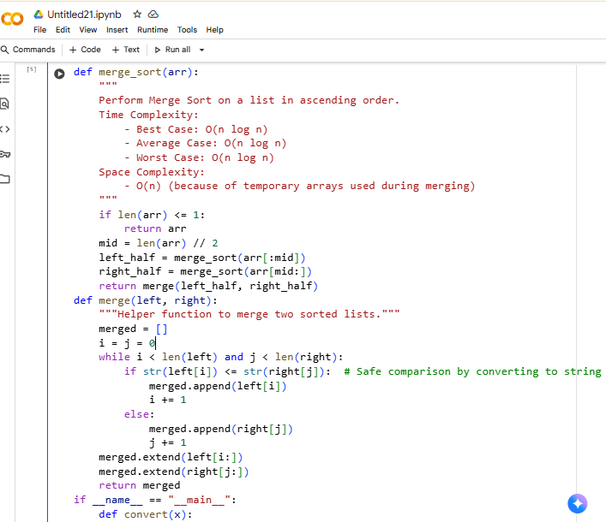  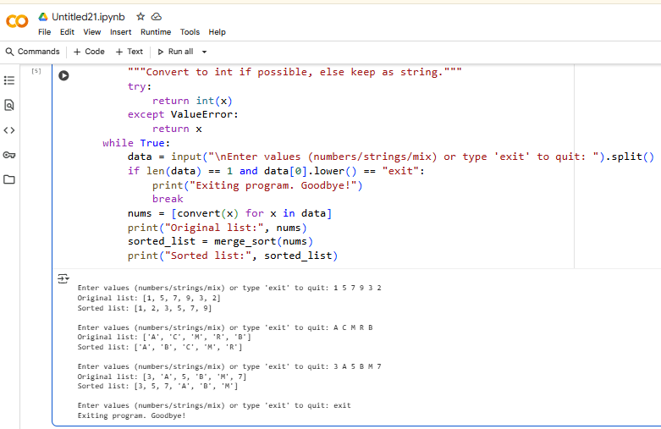  Observations:  - Write a Python program that asks the user to enter a list of numbers.  - Sort that list in ascending order using the Merge Sort algorithm.  - Create a function called merge_sort(arr) that performs the sorting.  - Inside the function, add a docstring that explains its time complexity (best, average, worst) and space complexity.  Task Description #2 (Searching – Binary Search with AI Optimization)  - Task: Use AI to create a binary search function that finds a target element in a sorted list.  - Instructions:  - Prompt AI to create a function binary_search(arr, target) returning the index of the target or -1 if not found.  - Include docstrings explaining best, average, and worst-case complexities.  - Test with various inputs.  - Expected Output:  - Python code implementing binary search with AI-generated comments and docstrings.  Prompt:  - Write a Python function binary_search(arr, target) that searches for a target value in a sorted list.  - Return the index of the target if found; otherwise, return -1.  - Include a docstring explaining the best, average, and worst-case time complexity, and allow user input for the list and target.  Code:  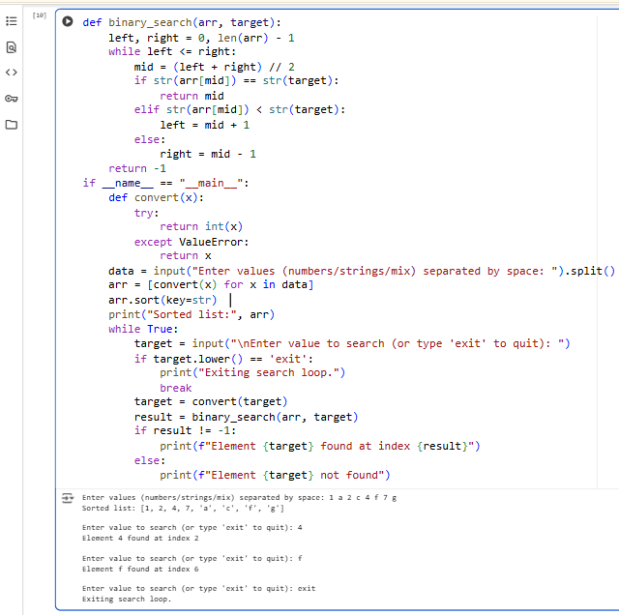  Observations:  - The function performs an efficient search by halving the list repeatedly until the target is found or ruled out.  - It returns the index of the target if present; otherwise, it returns -1.  - In the best case, the target is right in the middle — time complexity is O(1).  - On average and in the worst case, it takes O(log n) time due to the repeated division of the list.  - It works with any sorted list of comparable elements — numbers, strings, etc.  - The implementation uses a while loop instead of recursion, which helps conserve memory.  Task Description #3 (Real-Time Application – Inventory Management System)  - Scenario: A retail store’s inventory system contains thousands of products, each with attributes like product ID, name, price, and stock quantity. Store staff need to:  - Quickly search for a product by ID or name.  - Sort products by price or quantity for stock analysis.  - Task:  - Use AI to suggest the most efficient search and sort algorithms for this use case.  - Implement the recommended algorithms in Python.  - Justify the choice based on dataset size, update frequency, and performance requirements.  - Expected Output:  - A table mapping operation → recommended algorithm → justification.  - Working Python functions for searching and sorting the inventory.  Prompt:  1. Use a dictionary for fast product lookup by ID or name.  2. Sort the product list using Python’s sorted() with a key for price or quantity.  3. Write functions that take user input to search and sort the products accordingly.  Code:  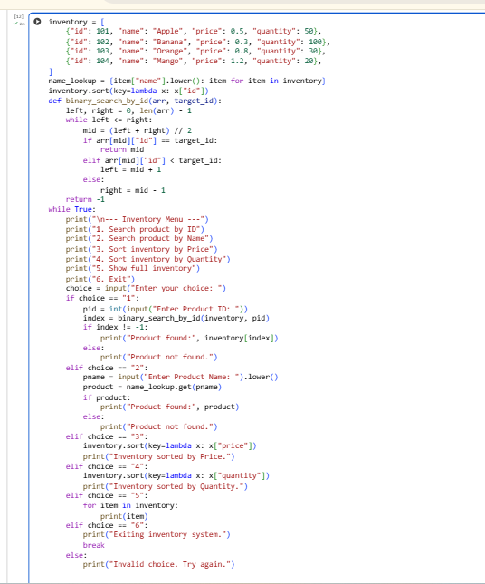  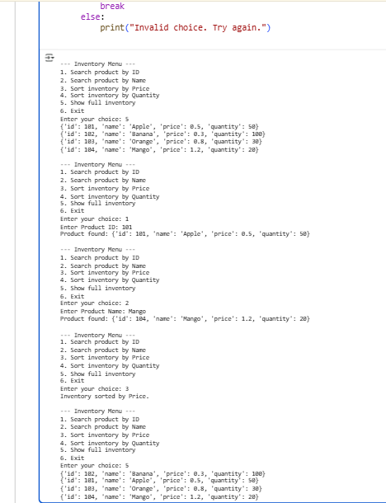  Observations:  - For searching by name, linear search works fine for small datasets, but a dictionary is better if names are unique.  - To sort by price or quantity, Python’s built-in sorted() (based on Timsort) or Merge Sort are both efficient and scalable.  - Binary search only works on sorted data, while dictionary lookups typically offer constant-time performance — O(1).  - These approaches strike a good balance between speed and memory usage, making them ideal for managing large inventories with occasional updates.  ✅ Deliverables (For All Tasks)  - AI-generated prompts for code and test case generation.  - At least 3 assert test cases for each task.  - AI-generated initial code and execution screenshots.  - Analysis of whether code passes all tests.  - Improved final version with inline comments and explanation.  - Compiled report (Word/PDF) with prompts, test cases, assertions, code, and output. |  |  |  |  |  | Week6 - Monday

